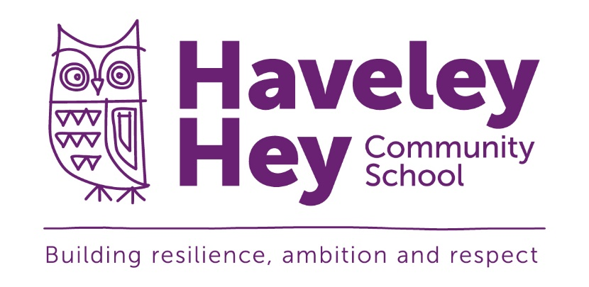

Haveley Hey
Pupil Premium Report

2020-2021

Haveley Hey Pupil Premium Report 2020-2021
OBJECTIVES FOR PUPIL PREMIUM IN THIS SCHOOL
- The Pupil Premium will be used to provide additional educational support to improve the progress and to raise the standard of achievement for these pupils
- The funding will be used to narrow and close the gap between the achievement of these pupils and their peers
- As far as its powers allow the school will use the additional funding to address any underlying inequalities between children eligible for Pupils Premium and others, including tackling barriers to learning such as attendance and behaviour
- We will ensure that the additional funding reaches the pupils who need it most and that it makes a significant impact on their education and lives.
Value of the Pupil Premium Grant for the year 2020-2021
 |  | Budget | Actual
FSM element | No. of pupils | 279
 | Per pupil rate | £1,320
 | Sub-total | £368,100
LAC element | No. of pupils | 6
 | Per pupil rate | £1,800
 | Sub-total | £10,800
Service element | No. of pupils | 0
 | Per pupil rate | £300
 | Sub-total | 0
Nursery Pupil Premium |  | £10,271
Total Grant |  | £389,171
Total expenditure identified |  | £389,796
Balance to allocate |  | -£625

STRATEGY FOR USING THE FUNDING
The school has looked carefully at the needs of each pupil and we have decided to use the following intervention strategies:
- Providing small group work for targeted pupils entitled to PP funding with an experienced teacher focussed on overcoming gaps in learning to help them make improved progress and to raise their standards of achievement
- Providing professional development for teachers in order to improve teaching in Writing and Reading
- 1:1 support for pupils entitled to PP funding to help them make improved progress and to raise their standards of achievement,
- Additional teaching and learning opportunities for pupils entitled to PP funding provided through trained TAs or external agencies, to help them make improved progress and to raise their standards of achievement
- Acquiring effective materials for pupils entitled to PP funding aimed at raising standards, particularly in reading and mathematics,
- All our work through the Pupil Premium is aimed at accelerating progress moving pupils entitled to PP funding to at least age related expectations. Initially this will always include basic Literacy and Numeracy skills
- Resources will also been used to provide opportunities that develop pupils talents in all curriculum areas,
- Providing Breakfast club, including staffing and resources for pupils entitled to PP funding,
- Providing a range of extra-curricular activities across and beyond the whole school day
- Providing specialist human resources and interventions in order to enable all pupils entitled to PP funding to access all possible personal, social and educational opportunities.

Expenditure category | Allocated  Expenditure | Actual  Expenditure | Strategy for using the funding
Specialist Provision- IT Equipment,  Music Tuition, 1:1 Reading TAs and Behaviour Support | £100,993 |  | To provide a variety of support and input from specialists including music, SEND additional provision based at The Bridge, Specific staff working 1:1 with targeted pupils for reading, behaviour support TA3, IT resources within school to meet the demands of the new NC
Targeted support and intervention | £152,032 |  | Specific targeted teaching delivered by Beehive Nurture provision, Anchor Education, SALT, City in the Community, FFT, Specialist SEND teachers, EP support and Passport to Learning
Life skills and experience | £49,255 |  | Extending children’s life experiences and enriching the curriculum through trips, residential trips and visitors. Enriching the curriculum through extending learning beyond the classroom providing a broad, balanced range of experiences. e.g. Wild Tribe, residential visits to London and Ghyll Head, garden and woodwork.
Rights Respecting Programme | £17,699 |  | Providing Pupil Parliament leadership, Residential opportunities and Unicef programme
Lunchtime Activities | £4,244 |  | To ensure that all children feel safe at all times of the day providing relevant small group or 1:1 support and ensures that they are able to get straight onto learning after lunch.
Every Child a Reader | £1,800 |  | Development of the reading environments throughout the school to foster a love of reading. Ensure the best resources are available to all children
Before / after school programme | £2,500 |  | To ensure high quality provision outside of the school day supporting healthy life choices and supporting children with homework as well as developing problem solving and team work
Parent Support / Community Liaison | £26,611 |  | Providing support to families ensuring safeguarding of pupils which impacts directly on Children’s well-being and readiness to learn. This forms a valuable part of our Early Help initiatives within school
Uniform / Refreshments | £4,525 |  | To ensure that all children are equipped to enable them to participate fully in school life
Gifted and Talented | £1,000 |  | Proving opportunities for able pupils to develop talents and ensure they achieve their true potential in cooperation with MGS, Lifestyle Centre and other partners
Attendance and punctuality | £29,137 |  | Providing support to families and staff vis an attendance officer, incentives and rewards, ensuring all children are in school every day and on time to access the curriculum and maximise learning.
Total Allocated for 2020-21 | £389,796
Total received for 2020-21 | £389,171
Total remaining / carry forward to next academic year | -£625

