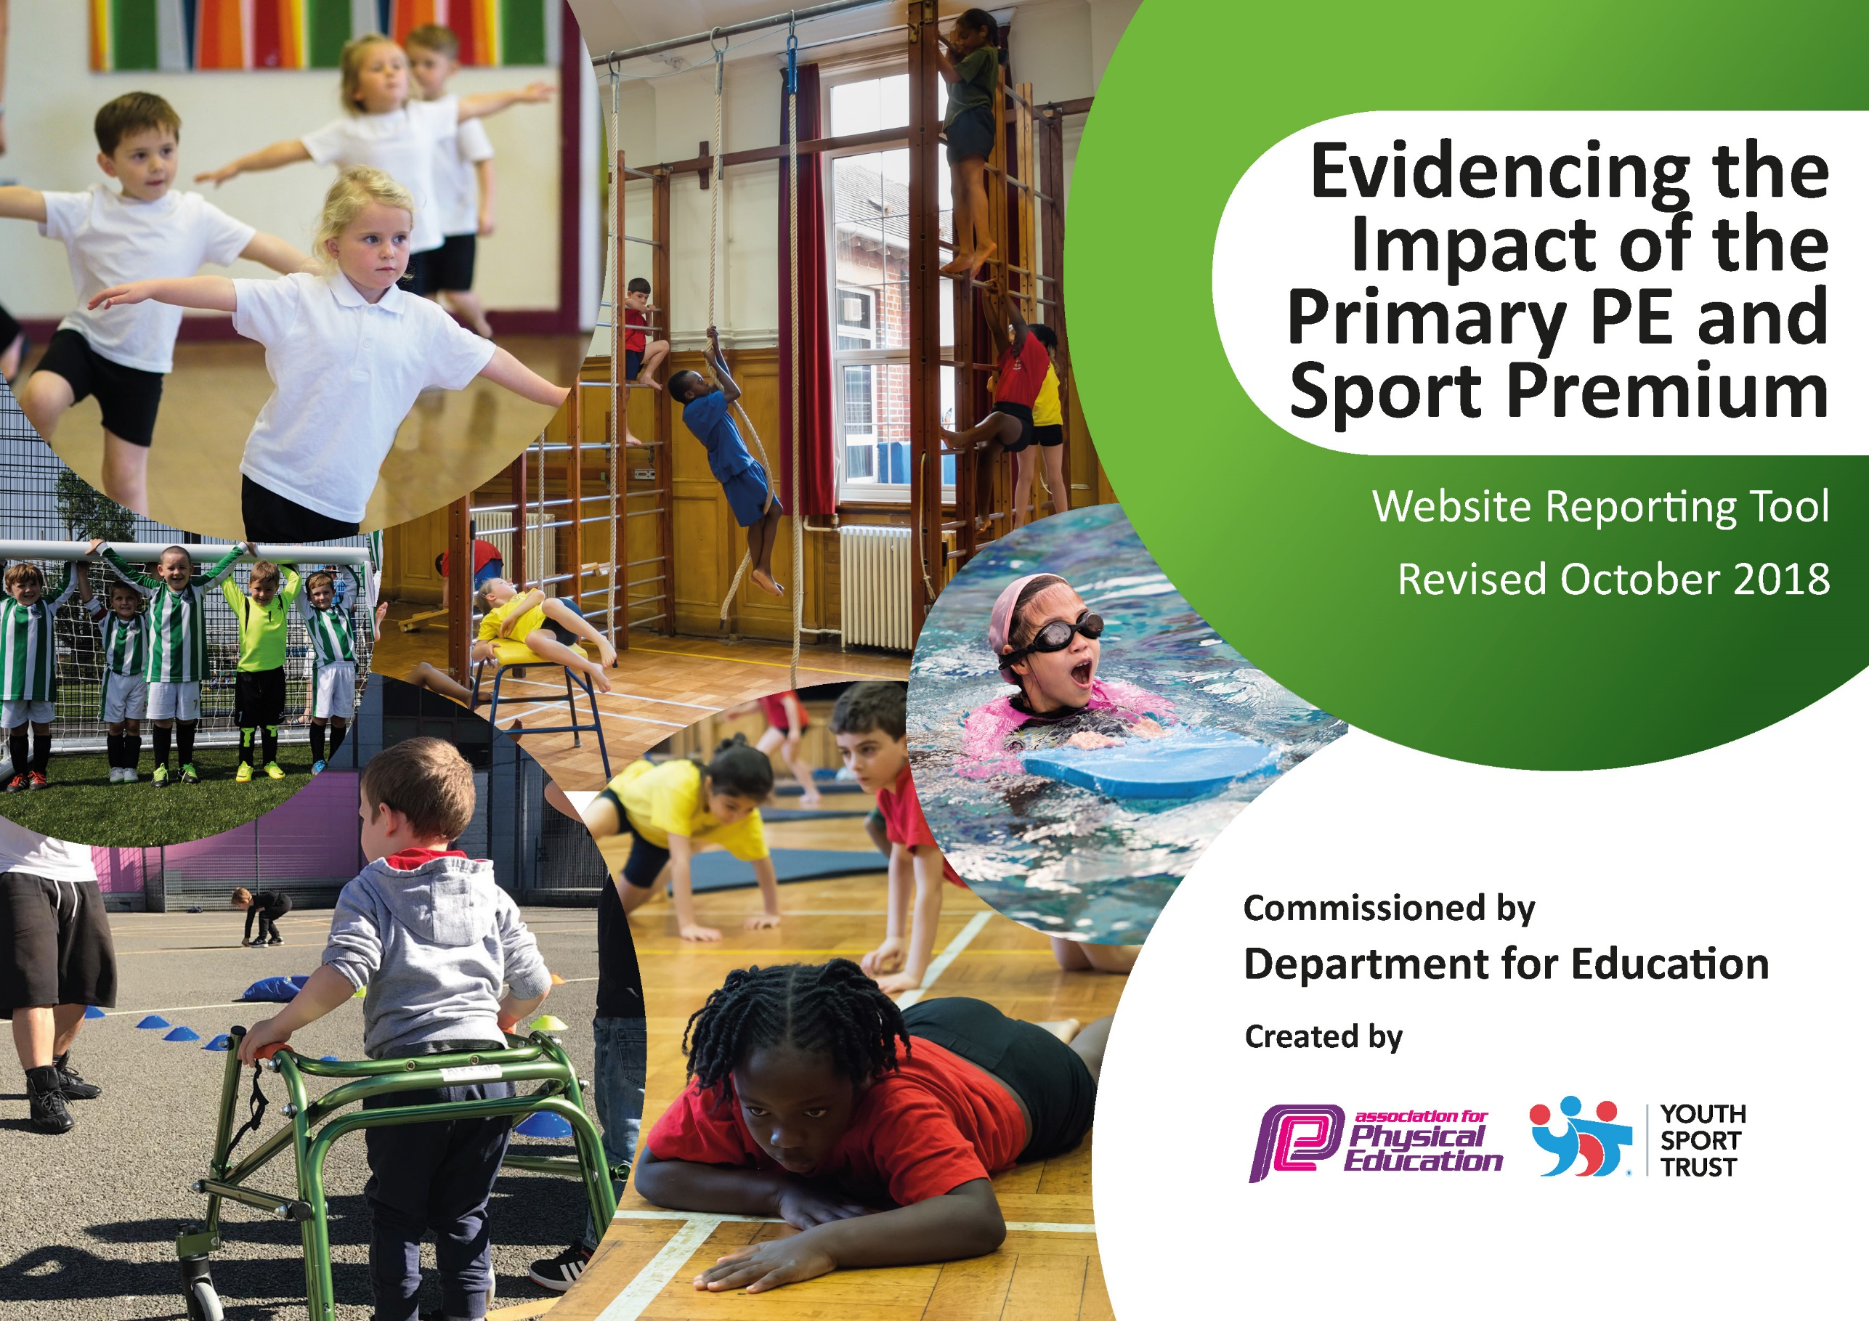
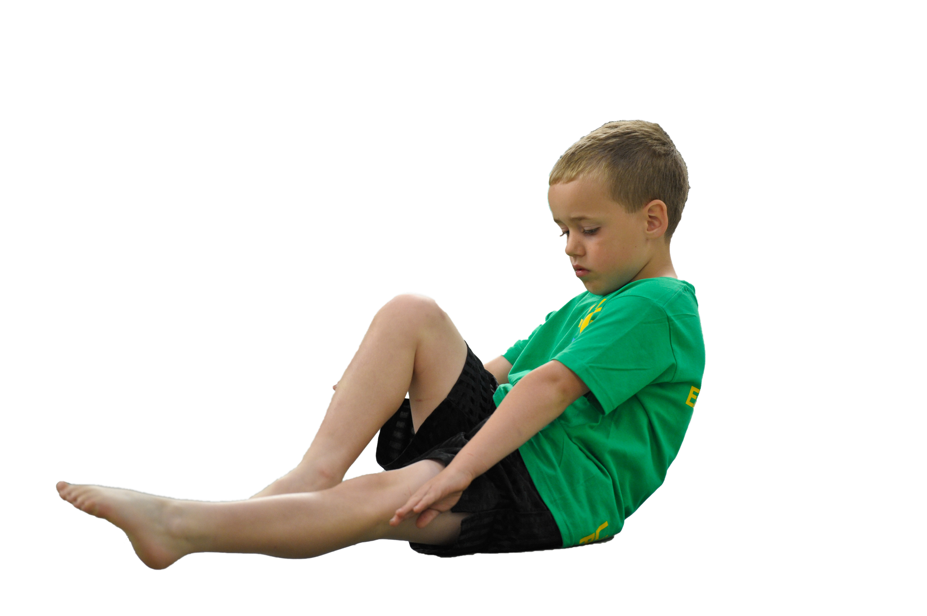
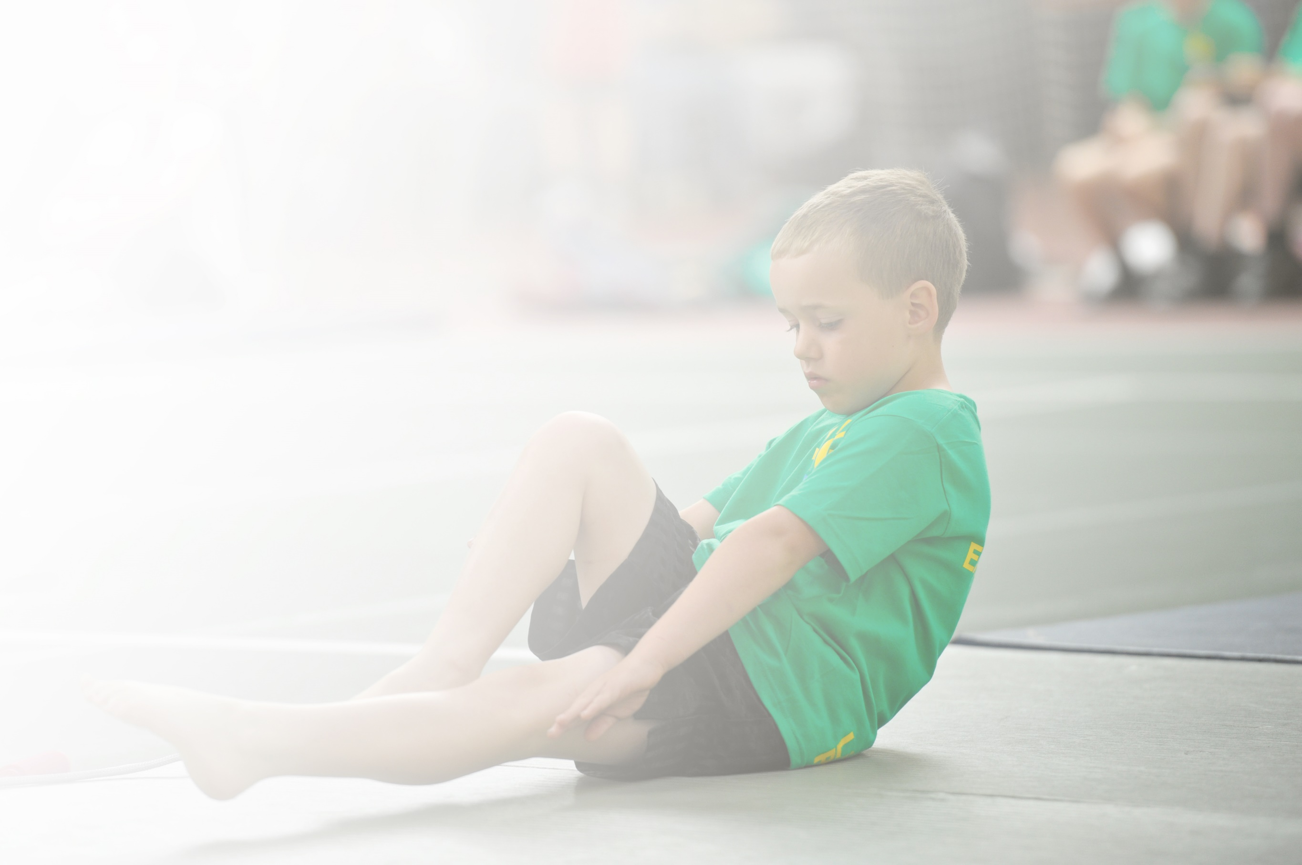
Schools must use the funding to make additional and sustainable improvements to the quality of Physical Education, Sport and Physical Activity (PESPA) they offer. This means that you should use the Primary PE and Sport Premium to:

- Develop or add to the PESPA activities that your school already offer
- Build capacity and capability within the school to ensure that improvements made now will benefit pupils joining the school in future years

Please visit gov.uk for the revised DfE guidance including the 5 key indicators across which schools should demonstrate an improvement. This document will help you to review your provision and to report
your spend. DfE encourages schools to use this template as an effective way of meeting the reporting requirements of the Primary PE and Sport Premium.

We recommend you start by reflecting on the impact of current provision and reviewing the previous
spend. Under the Ofsted Schools Inspection Framework, inspectors will assess how effectively leaders use the Primary PE and Sport Premium and measure its impact on outcomes for pupils, and how effectively governors hold them to account for this.

Schools are required to publish details of how they spend this funding as well as on the impact it has on pupils’ PE and sport participation and attainment by the end of the summer term at the
latest.
We recommend regularly updating the table and publishing it
on your website throughout the year, as evidence of your
ongoing review into how you are using the money to
secure maximum, sustainable impact. To see an
example of how to complete the table please
click HERE.

Support for review and reflection - considering the 5 key indicators from DfE, what development needs are a priority for your setting and your students now and why? Use the space below to reflect on previous spend, identify current need and priorities for the future.

Meeting national curriculum requirements for swimming and water safety | Please complete all of the below:
What percentage of your current Year 6 cohort swim competently, confidently and proficiently over a distance of at least 25 metres?  N.B. Even though your children may swim in another year please report on their attainment on leaving  primary school. | 78%
What percentage of your current Year 6 cohort use a range of strokes effectively [for example, front crawl, backstroke and breaststroke]? | 48%
What percentage of your current Year 6 cohort perform safe self-rescue in different water-based situations? | 100%
Schools can choose to use the Primary PE and Sport Premium to provide additional provision for swimming but this must be for activity over and above the national curriculum requirements. Have you used it in this way? | No

Action Plan and Budget Tracking
Capture your intended annual spend against the 5 key indicators. Clarify the success criteria and evidence of impact that you intend to measure to evaluate for students today and for the future.

Academic Year: 2022/2023 | Total fund allocated: £19,490 |  |  | Date Updated: September 2023
Key indicator 1: The engagement of all pupils in regular physical activity – Chief Medical Officer guidelines recommend that primary school children undertake at least 30 minutes of physical activity a day in school |  |  |  |  |  |  | Percentage of total allocation:
 |  |  |  |  |  |  | 4%
School focus with clarity on intended impact on pupils: | Actions to achieve: |  |  | Funding allocated: |  | Evidence and impact: | Sustainability and suggested next steps:
- Increased participation in physical activity and ideas to take away for themselves. | - Specialist PE coach (Freddy Fit) delivered sessions to all classes and play ground leader training to selected children |  |  | £780 |  | - More children are participating in physical activity at break and lunch time.  - Children that have been trained as playground leaders help set up and run different games for their peers. | - Playground leaders embedded and a TA paid to lead on this.
Key indicator 2: The profile of PESSPA being raised across the school as a tool for whole school improvement |  |  |  |  |  |  | Percentage of total allocation:
 |  |  |  |  |  |  | 0%
School focus with clarity on intended impact on pupils: | Actions to achieve: |  |  | Funding allocated: |  | Evidence and impact: | Sustainability and suggested next steps:
- Introduce sports council  - Introduce playground leaders  - Sports Council to deliver an assembly  - Increase links with community clubs | - PE lead to establish sports council and sports captain  - PE lead to establish Playground leaders  - PE lead to organise and facilitate sports councillors lead an assembly  - Use twitter and send flyers out to parents promoting local sport clubs. |  |  | £0  £0  £0  £0 |  | - Sports council has helped deliver playground leaders, intra-competitions and assembly  - More children have engaged in physical activity during break time and lunch time  - Children are aware of benefits and the impact it can have on their lives. | - Sports council to continue in next academic year  - TA employed to help deliver playground leaders  - Sports Captains introduced to further increase the profile of sport  - Sport awards handed out in assemblies from inter and intra school competitions.
Key indicator 3: Increased confidence, knowledge and skills of all staff in teaching PE and sport |  |  |  |  |  |  |  | Percentage of total allocation:
 |  |  |  |  |  |  |  | 65%
School focus with clarity on intended  impact on pupils: |  | Actions to achieve: | Funding  allocated: |  | Evidence and impact: |  |  | Sustainability and suggested  next steps:
- Improved CPD for teachers  - New curriculum focused to the school and context it is in.  - Equipment purchased to enable staff to plan and teach lessons to a high standard |  | - Specialised sports coach to team teach with teachers on specific parts of teaching e.g. subject knowledge, organisation, behaviour management (sportspoint)  - PE lead to create medium term plans for each unit of work.  - Create links with Manchester Grammar School to deliver CPD to our staff  - Purchase equipment specific to the sports being taught in the curriculum.  - Ask teachers what equipment they would like for their lessons. | £12,245  £0  £0  £453.70 |  | - Increased amount of teaching of curriculum based PE.  - Statements from teachers stating they are now more confident in teaching PE and using different equipment.  - New equipment purchased  - Increased amount of teaching in PE as there is equipment to do so. |  |  | - Monitoring of progress folders in spring 2 and summer 2  - Audit of PE cupboard and to order any more equipment that has become broken or decreased amounts  - Staff voice asking for what they want.
Key indicator 4: Broader experience of a range of sports and activities offered to all pupils |  |  |  |  |  |  |  | Percentage of total allocation:
 |  |  |  |  |  |  |  | 19%
School focus with clarity on intended  impact on pupils: |  | Actions to achieve: | Funding  allocated: |  | Evidence and impact: |  |  | Sustainability and suggested  next steps:
- Increased amount of sports on offer in curriculum  - Increased amount of sports in extra curricular |  | - PE lead to include different sports in the school curriculum  - Visitors to come in and deliver different sports  - Links with local sport clubs to offer taster sessions  - Use of current teachers skills to deliver different sports. | £3746 (TLR) |  | - Children are now accessing different sports in PE and revisiting them in different years “spiral curriculum”  - Freddy Fit delivers different sessions enabling children to take part in different sports and activities.  - Different teachers have delivered clubs within their expertise e.g. Lacrosse |  |  | - Continued monitoring of delivery and following of curriculum through learning walks and progress checks.  - Continued links between MGS and other sport clubs to continue exposure of different sports.
Key indicator 5: Increased participation in competitive sport |  |  |  |  |  |  |  | Percentage of total allocation:
 |  |  |  |  |  |  |  | 15%
School focus with clarity on intended  impact on pupils: |  | Actions to achieve: | Funding  allocated: |  | Evidence and impact: |  |  | Sustainability and suggested  next steps:
- Increase the amount of competitions “A” teams attend  - Increase the amount of competitions of “B” teams attend  - Increase the amount of intra-competitions |  | - School to be a part of Manchester PE association  - PE lead to actively use MPEA and to organise travel and staffing for competitions  - PE lead to manage and direct class teachers on how to organise intra-competitions and use sports council to support | £900 (Manchester PE Association)  £2,000 (Competition travel) |  | - A teams attended 6 inter-school competitions  - B teams attended 2 inter-competition  - An increased amount of children represented the school at competitions across Manchester.  - A dodgeball and rounders intra-competition were held supported by Sports Council  - All children in KS2, as long as they were present, participated in competitive games  - Sports Day was changed to a carousel format which meant more children participated in the events |  |  | - Continue being a part of Manchester PE Association  - Increase the number of “A” team competitions  - Increase the number of “B” team competitions  - Introduce a “C” team for selected competitions  - Increase the profile of the Sports Council  - More intra-competitions to allow more competitive situations and chances for sports council to lead  - Links with the other primary school in the trust to host termly competitions between the schools.  - Engage in virtual competitions with schools across Manchester.  - Increase intra-competitions within bubbles

