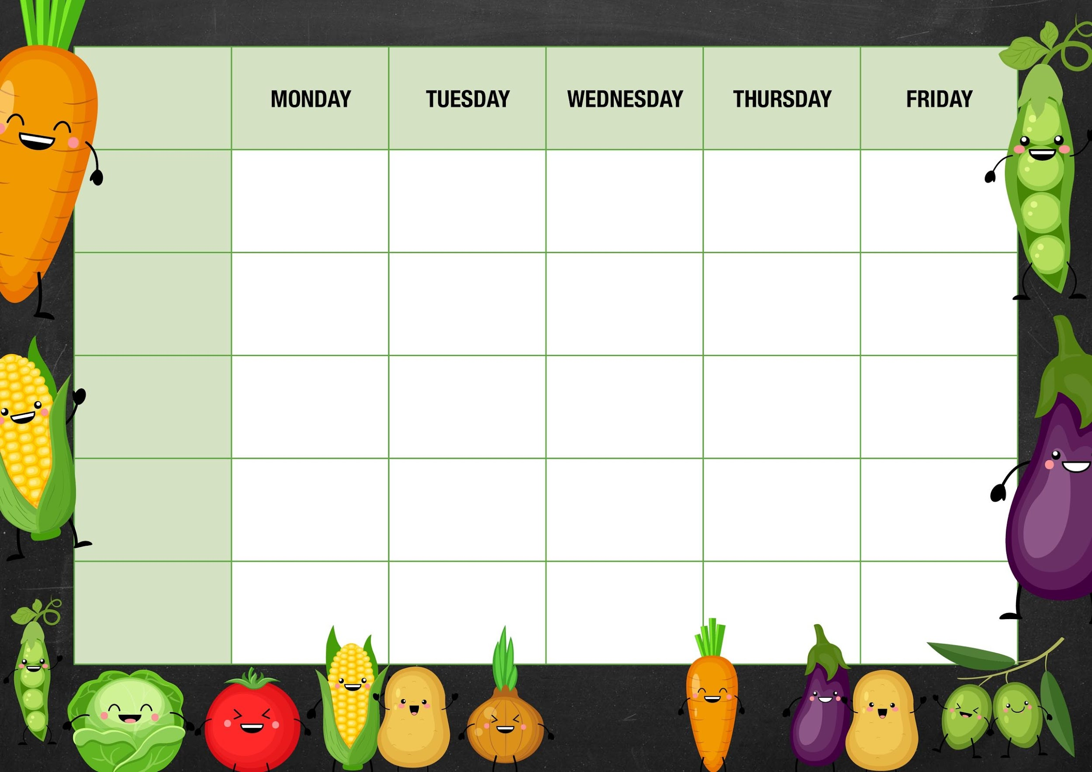MM

*Cheese and Onion Whirls served with Baby Potatoes and Baked Beans*

***Salad and Deli Bar***

***Week 2***

***Meat Free Monday***

*Quorn Tikka Masala with Sunshine Rice and Naan Bread*

***Vegetable***

***Jacket Potato Choice***

*Cottage Pie*

*Danish Meatball Biryani*

***Garden Peas***

*Choice of Baked Beans or Cheese*

*Vegetable Fingers served with Chips and Tomato Sauce*

*Vegetable Lasagna served with Garlic Bread*

*Roast Gammon with Roast Potato and all the trimmings*

*Cornflake Crunch*

*Jam Sponge and Custard*

*Cheese and Crackers*

*Strawberry Ice Cream Pot and Fruit*

*Chocolate Shortbread*

***Broccoli***

*Choice of Baked Beans Tuna or Cheese*

***Fishy Friday***

*Salmon Fish Fingers served with Chips and Tomato Sauce*

***Sweetcorn***

*Choice of Baked Beans or Cheese*

***Mixed Vegetables***

*Choice of Baked Beans or Cheese*

***Diced Carrots***

*Choice of Baked Beans Tuna or Cheese*

*Tomato and Mascarpone Pasta Bake*

*Deli Counter and a selection of fruit*

*Freshly Baked Bread*

*Deli Counter and a selection of fruit*

*Freshly Baked Bread*

*Deli Counter and a selection of fruit*

*Freshly Baked Bread*

*Deli Counter and a selection of fruit*

*Freshly Baked Bread*

*Cumberland Sausage with Roast Potato and all the trimmings*

*Deli Counter and a selection of fruit*

*Freshly Baked Bread*

***Mains***

***Vegetarian***

***Option***

***Dessert***