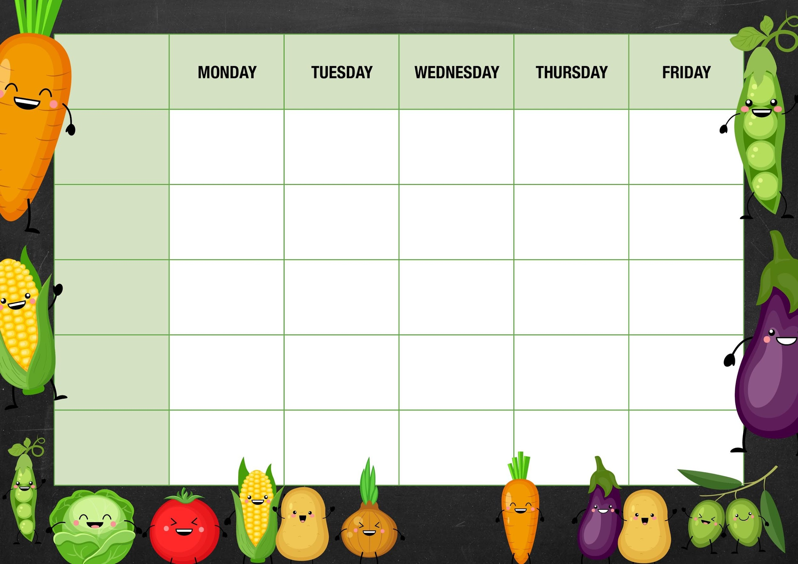 MM

***Carrot Batons***

*Choice of Baked Beans, Tuna, Cheese or Bolognese*

***Sweetcorn and Peppers***

*Choice of Baked Beans or Cheese*

*Spaghetti Bolognese served with Garlic Bread*

*Meat and Potato Puff Pastry Pie served with Baby Potatoes*

***Fishy Friday***

*Tempora Fish Goujons served with Ziggy Fries and Mushy Peas*

*Roast Chicken with Tidgy Puds and Creamy Mash*

***Meat Free Monday***

*Cheese and Tomato Pizza with Potato Wedges*

*Apple Crumble and Custard*

***Salad and Deli Bar***

*Muller Light Yoghurt with Fruit*

*Lancashire Biscuit*

*Chocolate Fudge Cake*

***Week 1***

***Mushy Peas***

*Choice of Baked Beans or Cheese*

*Deli Counter and a selection of fruit*

*Freshly Baked Bread*

*Vegetarian Sausage served with Ziggy Fries and Mushy Peas*

***Mains***

***Vegetarian***

***Option***

***Vegetable***

***Jacket Potato Choice***

***Garden Peas***

*Choice of Baked Beans Tuna or Cheese*

*Cheese and Bean Burritos served with Potato Puffs*

*Quorn Fillet with Tidgy Puds and Roast Potato and all the trimmings*

*Strawberry Ice Cream Pot*

*Quorn Sweet Chili*

*Noodles*

***Cabbage***

*Choice of Baked Beans or Cheese*

*Tomato and Basil Pasta Bake*

*Deli Counter and a selection of fruit*

*Freshly Baked Bread*

*Deli Counter and a selection of fruit*

*Freshly Baked Bread*

*Deli Counter and a selection of fruit*

*Freshly Baked Bread*

*Deli Counter and a selection of fruit*

*Freshly Baked Bread*

***Dessert***