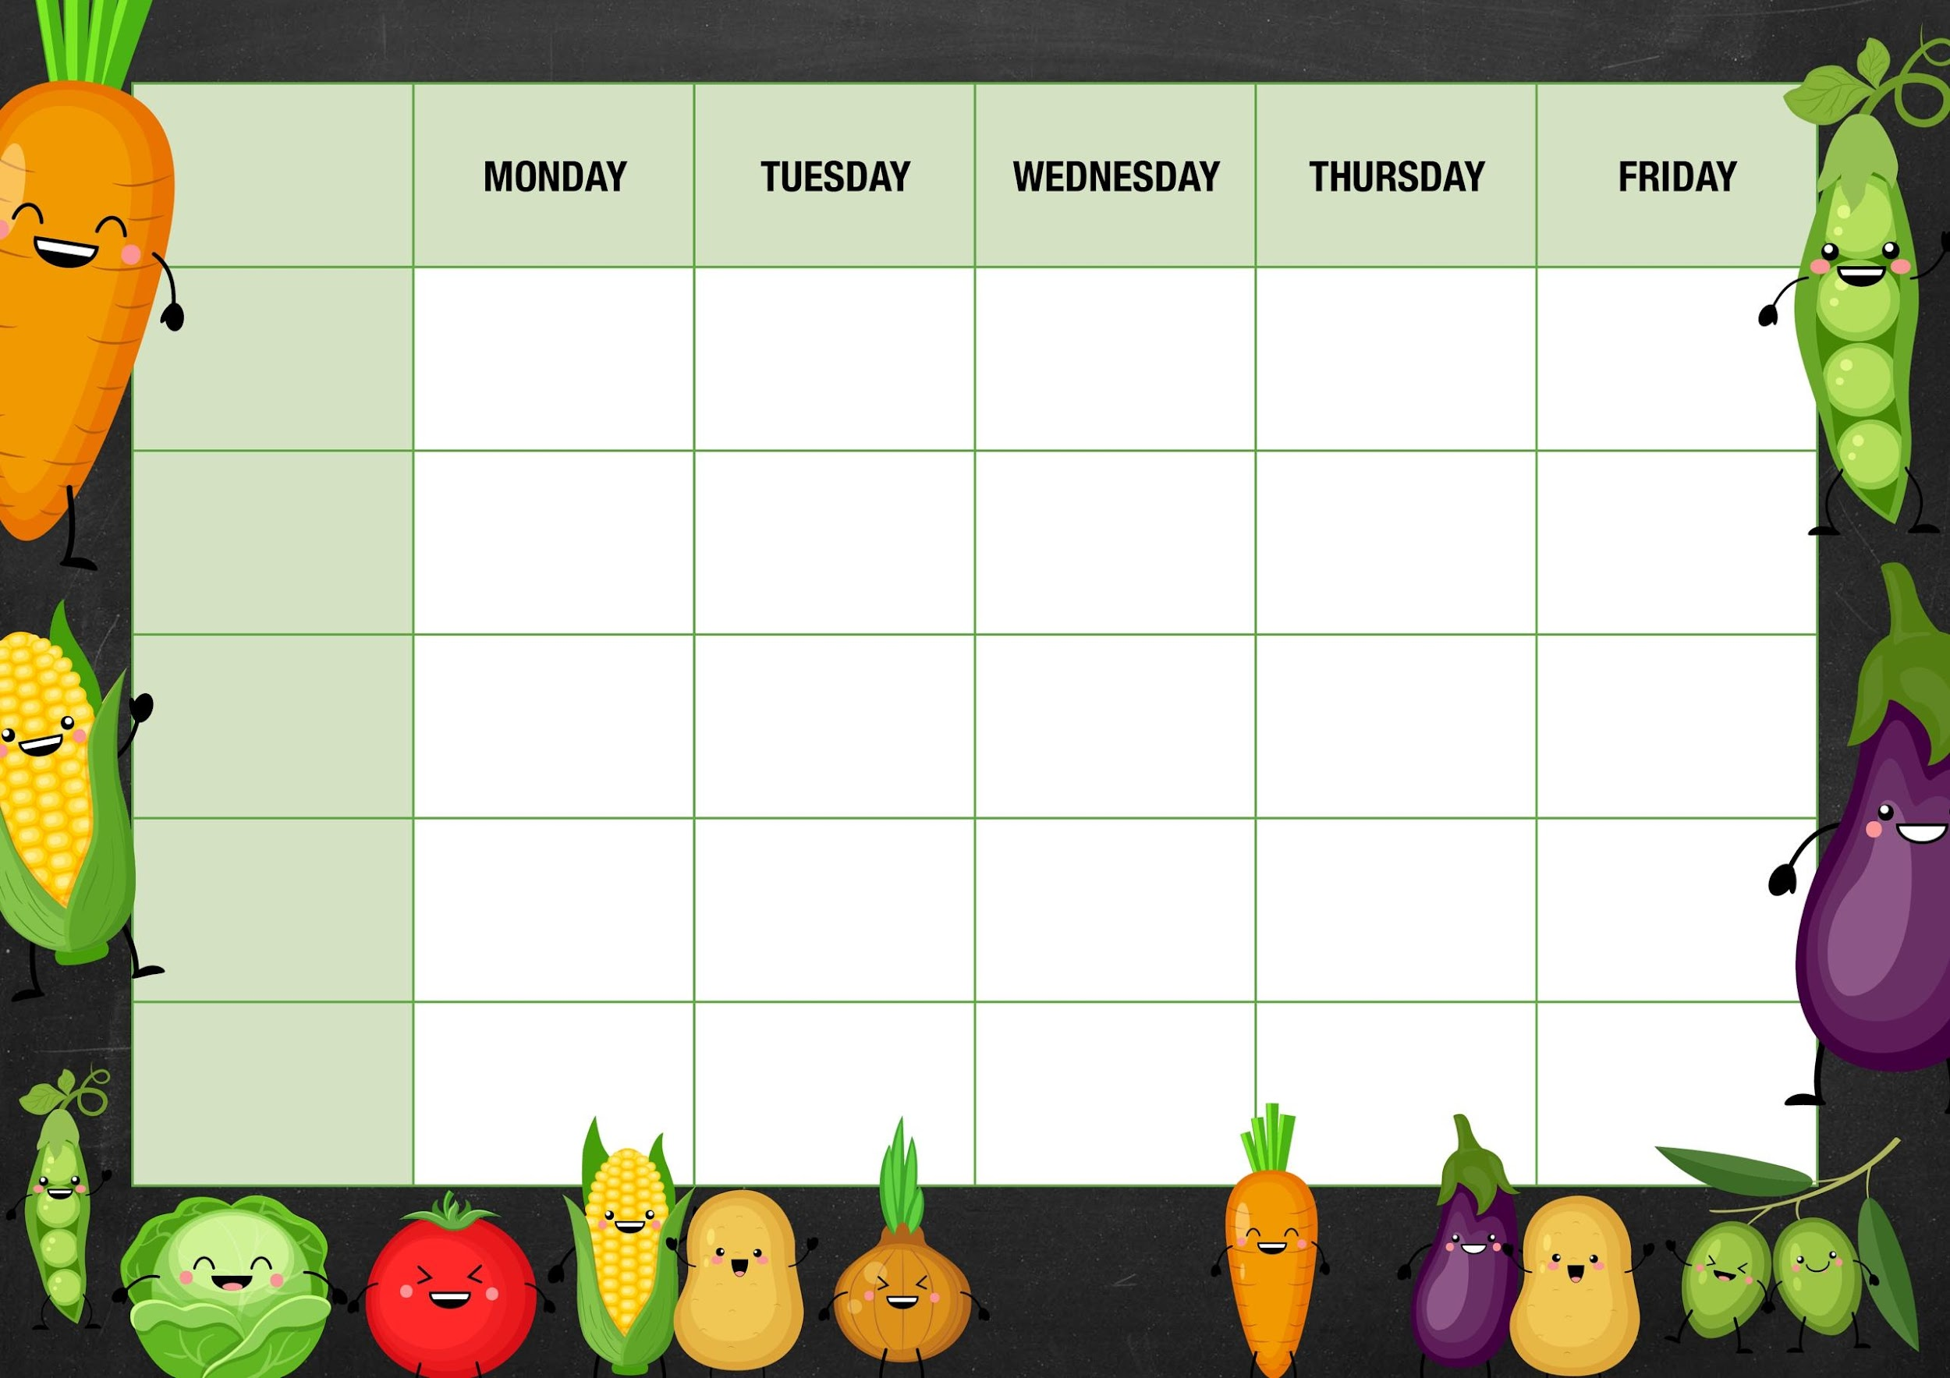 MM

Toasted cheese Panini with chips and ketchup

Sweetcorn/peas

Cheese and beans

Deli Counter and a selection of fruit

Freshly Baked Bread

Chicken dinner with roast potatoes Yorkshire puddings and gravy

Mushy peas

Tuna

Cheese and

Beans

Jam sponge and custard

Quorn fillet dinner with roast potatoes Yorkshire puddings and gravy

Tomato and basil pasta bake

***Week 3***

Choc chip muffin

Red onion/mango chutney

Tuna

Cheese and beans

Carrot/swede

Cheese and beans

Quorn korma with rice and naan bread

Cheese whirl mash and gravy

Sausage whirl mash and gravy

Mixed veg

Cheese and beans

Chicken korma with rice and naan bread

***Fishy Friday***

Salmon fish cakes with chips and ketchup

***Meat Free Monday***

Veg chili with rice

Strawberry jelly and fruit

***Salad and Deli Bar***

Frozen fruit mousse

***Mains***

***Vegetarian***

***Option***

***Vegetable***

***Jacket Potato Choice***

Choc ices

Deli Counter and a selection of fruit

Freshly Baked Bread

*Deli Counter and a selection of fruit*

*Freshly Baked Bread*

Deli Counter and a selection of fruit

Freshly Baked Bread

Deli Counter and a selection of fruit

Freshly Baked Bread

***Dessert***