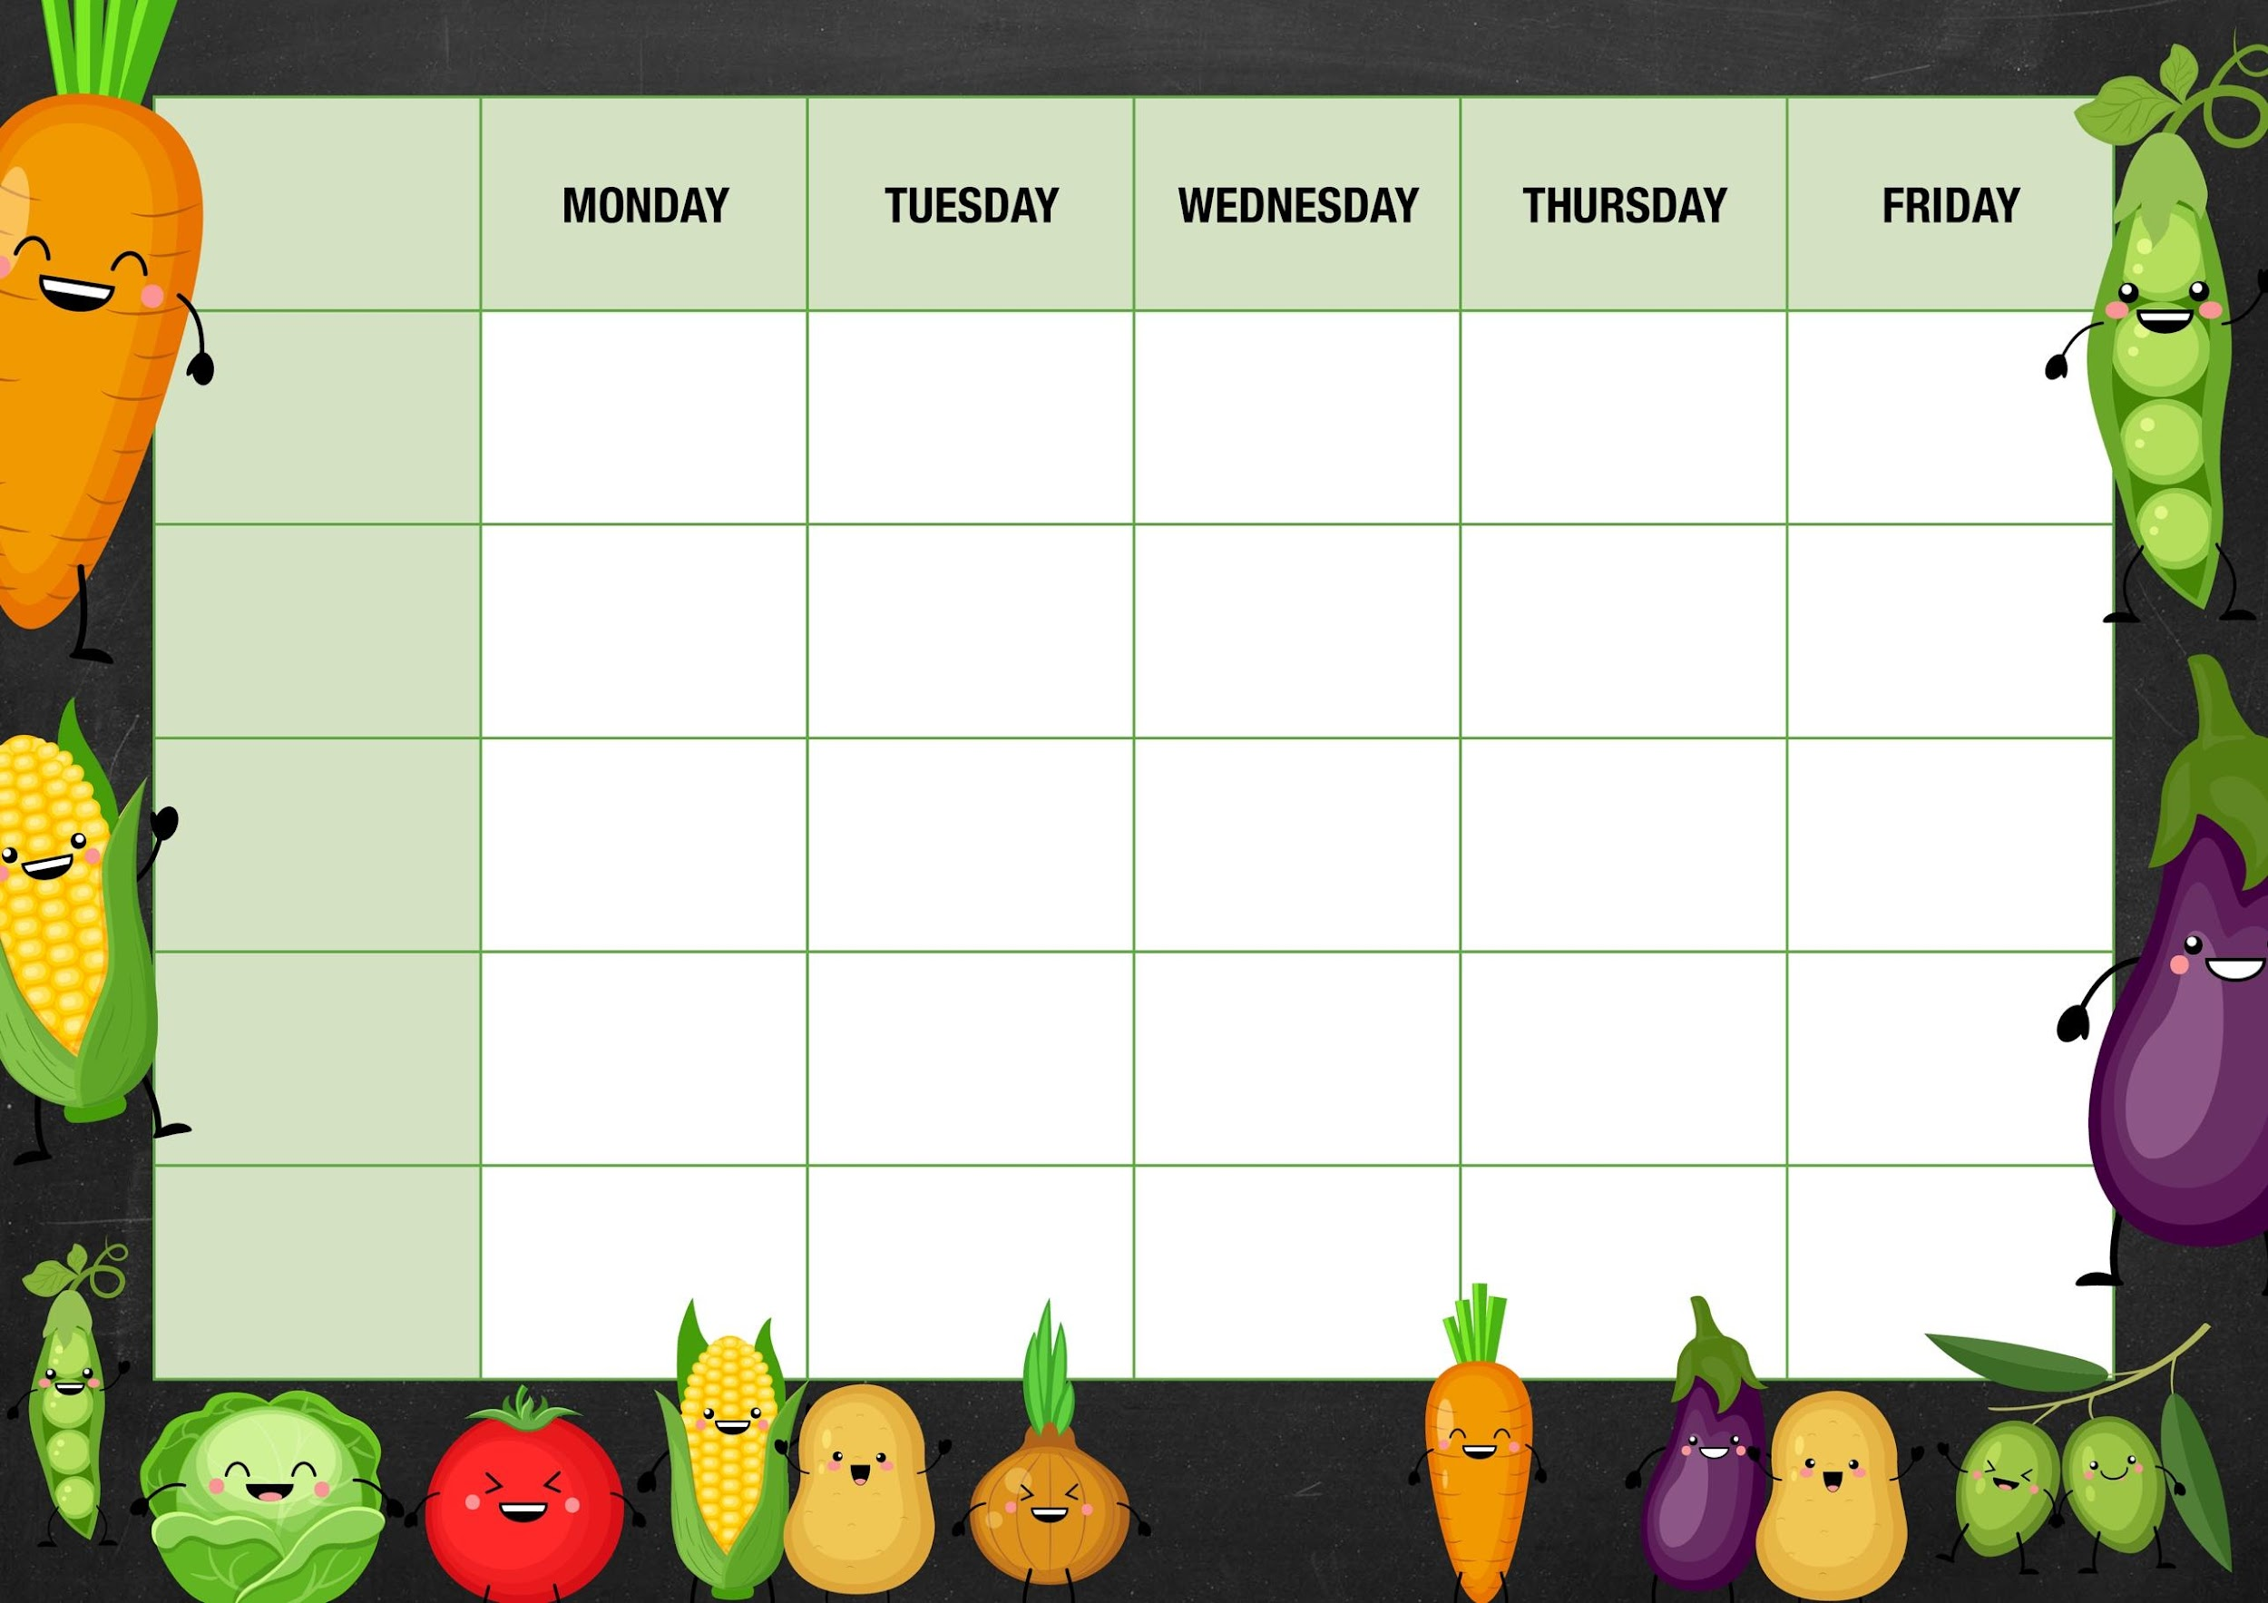 MM

Beans/Peas

Cheese and beans

Deli Counter and a selection of fruit

Freshly Baked Bread

Sweetcorn/peppers

Tuna

Cheese and

Beans

Lancashire biscuits

Vegetarian sausage mash and gravy

Sausage mash and gravy

Sweet potato Balti curry with rice and naan bread

Quorn nuggets with chunky chips and ketchup

***Week 2***

Cheese crackers and grapes

Carrots

Tuna

Cheese and beans

Beans

Cheese and beans

Tomato and basil pasta with garlic ciabatta slices

Cheese and tomato pizza with French fries

Peperoni pizza with French fries

Carrot batons

Cheese and beans

Beef lasagna with garlic ciabatta slices

***Fishy Friday***

Fish fingers with chunky chips and ketchup

***Meat Free Monday***

Macaroni cheese and garlic bread slices

Apple crumble and custard

***Salad and Deli Bar***

Choc and beetroot muffin

***Mains***

***Vegetarian***

***Option***

***Vegetable***

***Jacket Potato Choice***

Ice cream tubs with fruit cocktail

Deli Counter and a selection of fruit

Freshly Baked Bread

*Deli Counter and a selection of fruit*

*Freshly Baked Bread*

Deli Counter and a selection of fruit

Freshly Baked Bread

Deli Counter and a selection of fruit

Freshly Baked Bread

***Dessert***