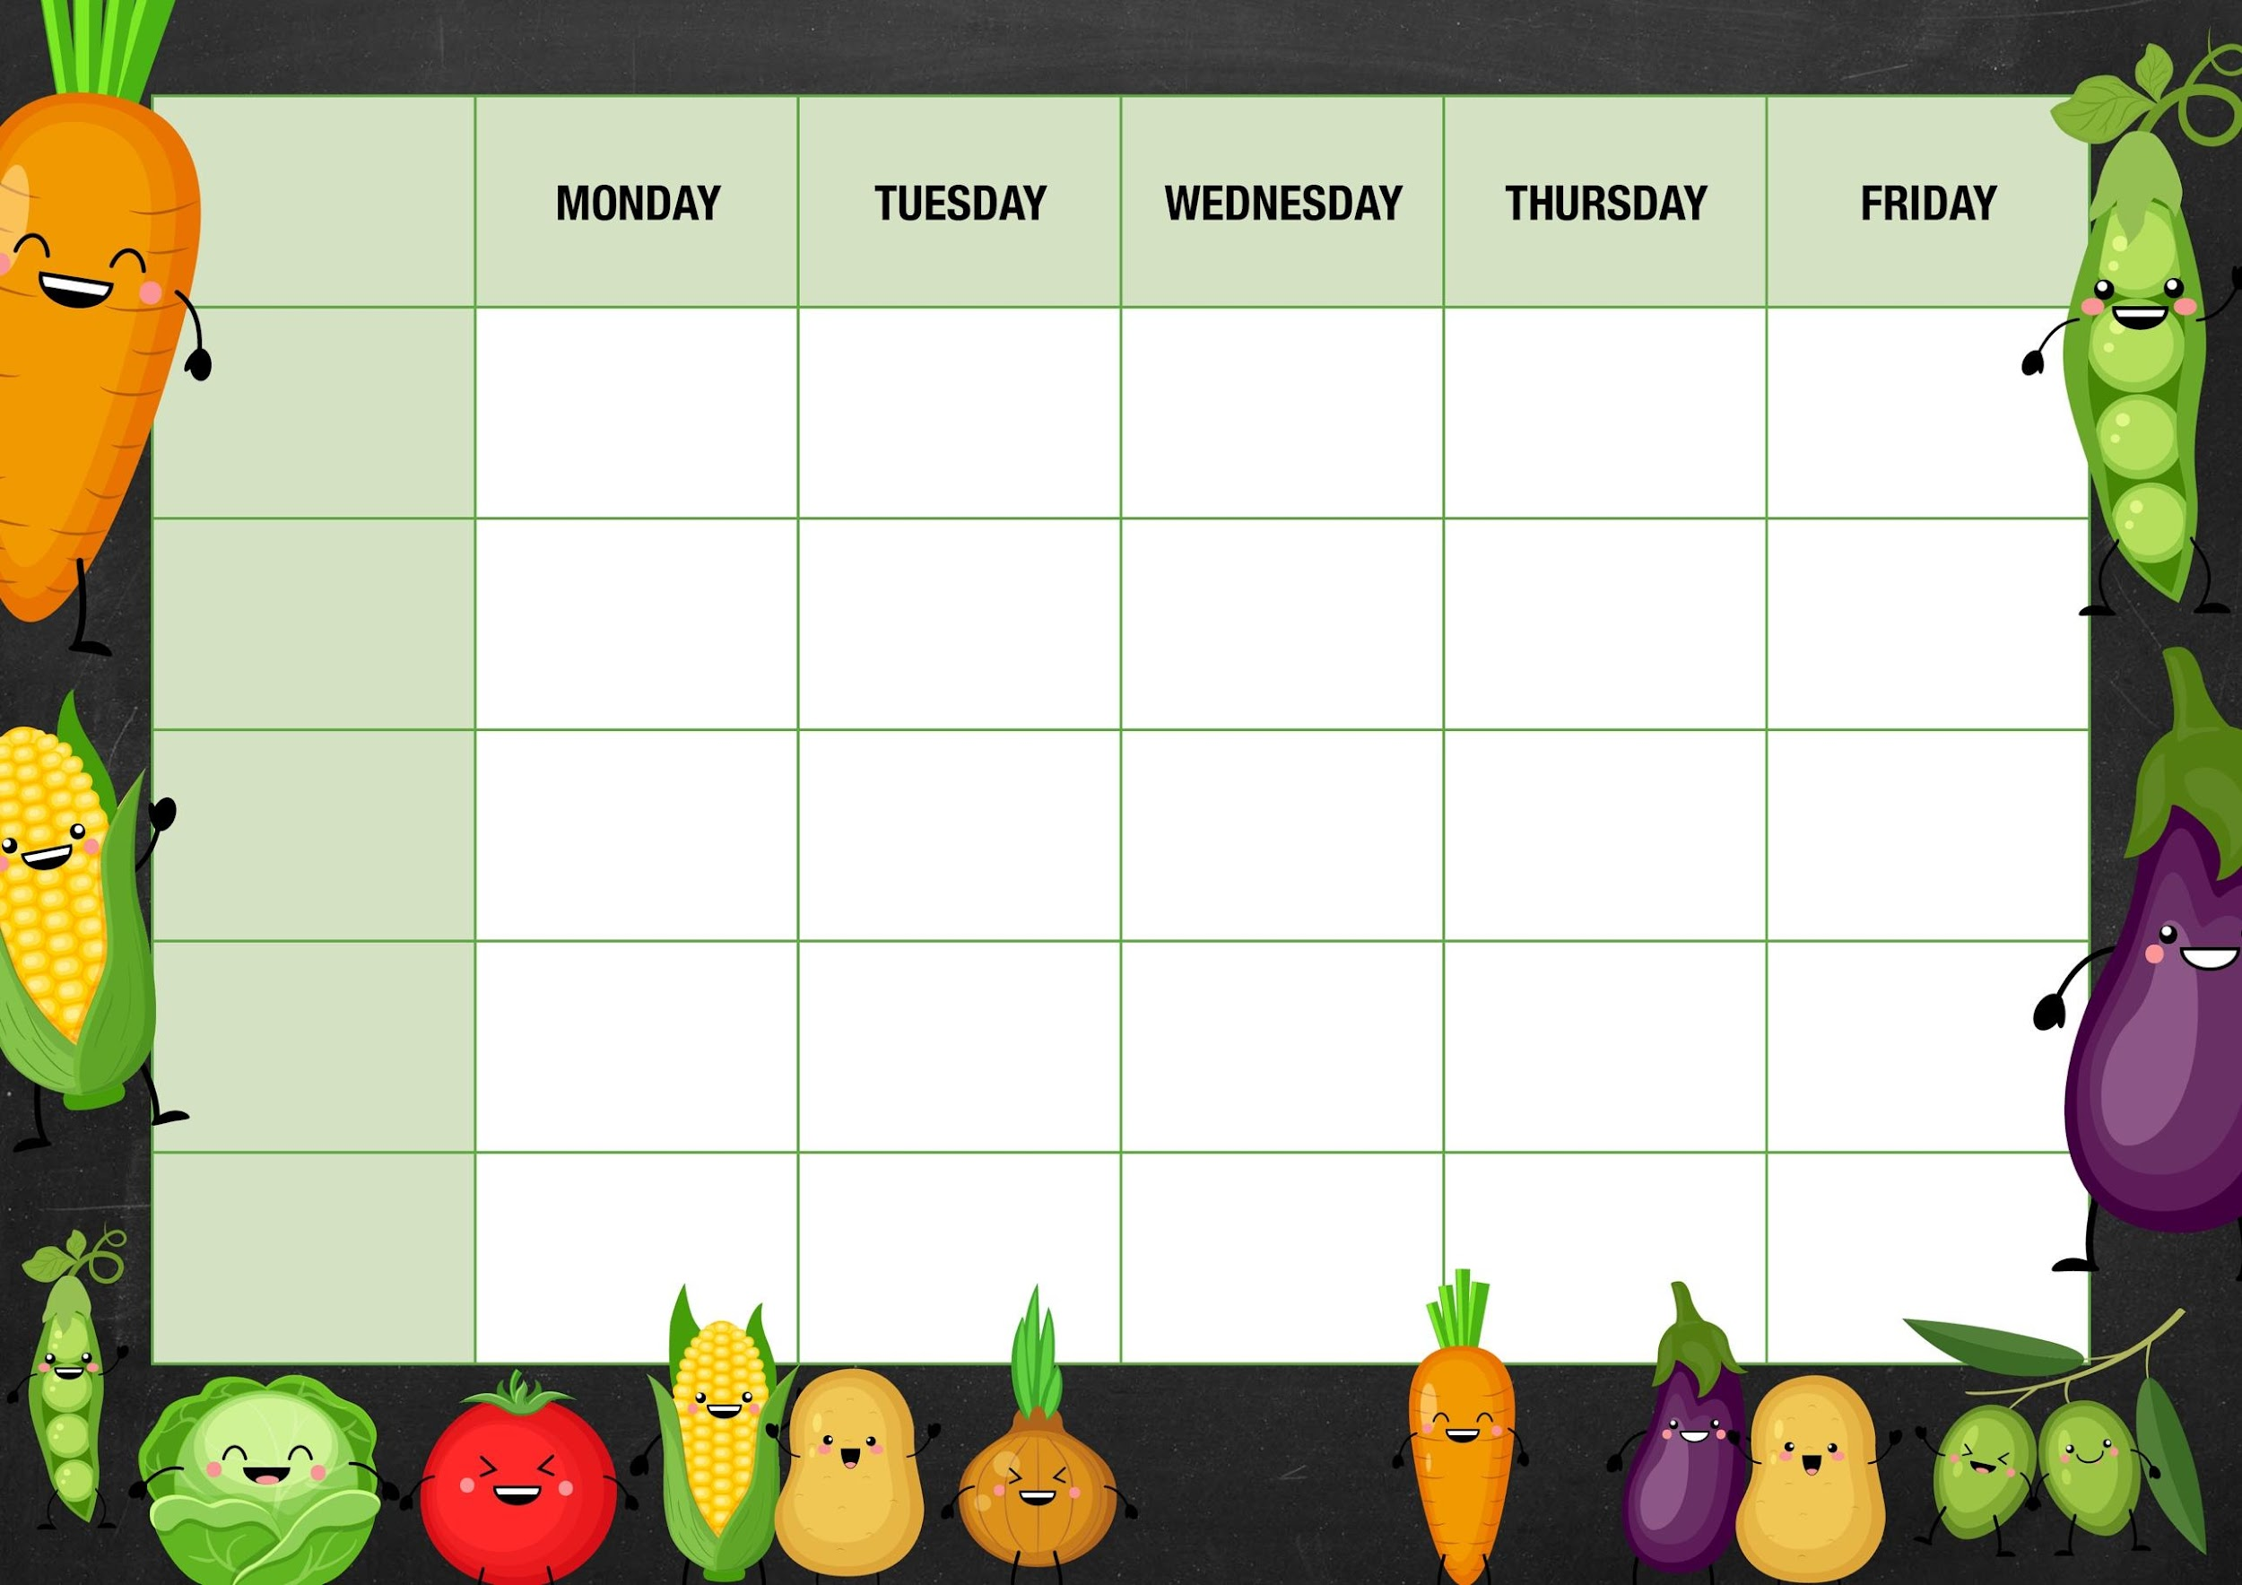 MM

Peas

Cheese and beans

Deli Counter and a selection of fruit

Freshly Baked Bread

Deli Counter and a selection of fruit

Freshly Baked Bread

Veggie meatballs with chunky veg and chips

Quorn cottage pie with crusty bread and beetroot

Choc chip cookies

Gammon roast dinner with roast potatoes Yorkshire pudding and gravy

Peas

Tuna

Cheese and

Beans

Old school sprinkle cake

Quorn roast with roast potatoes Yorkshire puddings and gravy

Tomato and mascarpone pasta with garlic bread

***Week 1***

Red cabbage

Tuna

Cheese and beans

Carrots

Cheese and beans

Quorn tikka with rice and naan bread

Chicken tikka with rice and naan bread

Mixed veg

Cheese and beans

Cottage pie with crusty bread and beetroot

***Fishy Friday***

Harry Ramsdens fish fillet with chips and ketchup

***Meat Free Monday***

Cheese pasty with mash potato and beans

Lemon sponge and custard

***Salad and Deli Bar***

Arctic roll and mandarins

***Mains***

***Vegetarian***

***Option***

***Vegetable***

***Jacket Potato Choice***

Smooth yoghurts and fruit

Deli Counter and a selection of fruit

Freshly Baked Bread

*Deli Counter and a selection of fruit*

*Freshly Baked Bread*

Deli Counter and a selection of fruit

Freshly Baked Bread

Deli Counter and a selection of fruit

Freshly Baked Bread

***Dessert***